CSCE-310 Database Systems

Homework 8

Raymond Zhu

923008555

Problem 1:

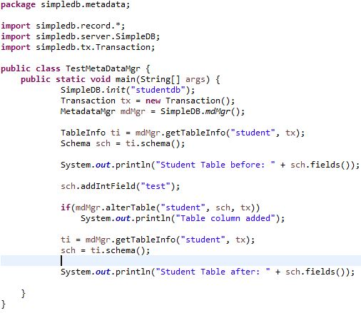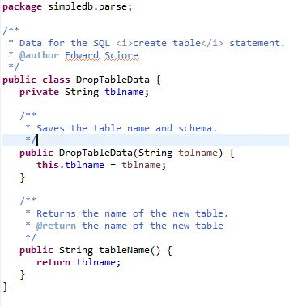

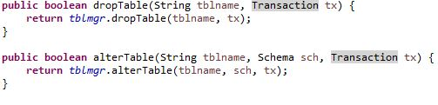

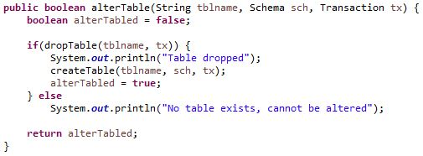

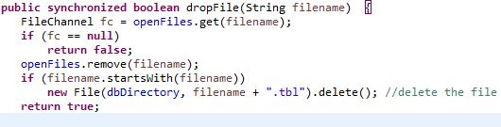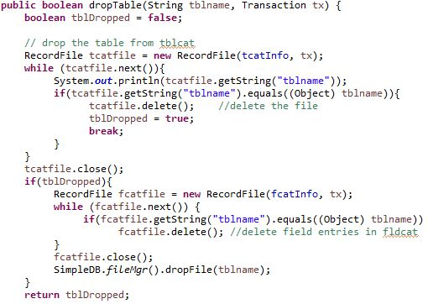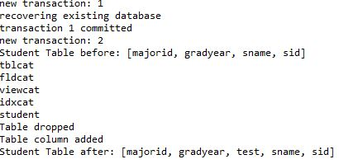

List of Classes used:

**BasicUpdatePlanner.java**

**DropTableData.java**

**FileMgr.java**

**IndexUpdatePlanner.javaParser.java**

**Lexer.java**

**MetadataMgr.java**

**Planner.java**

**TableMgr.java**

**TestMetaDataMgr.java**

**UpdatePlanner.java**

Problem 2:

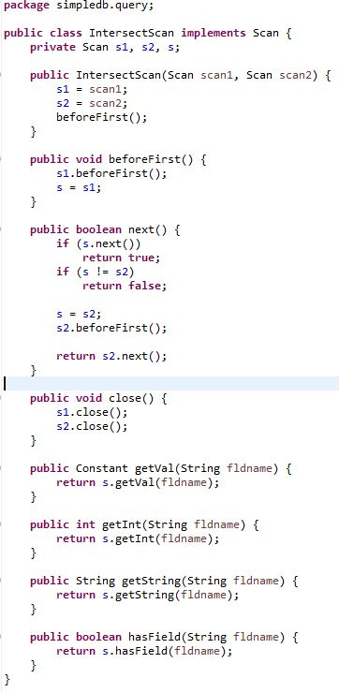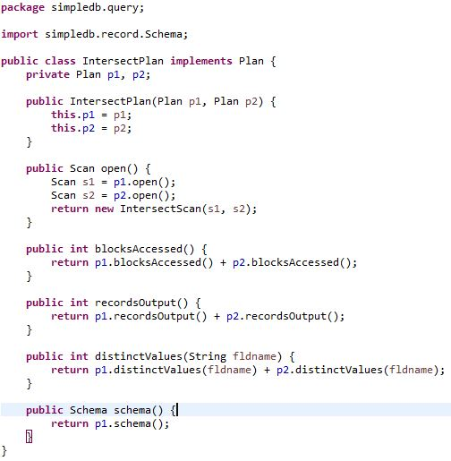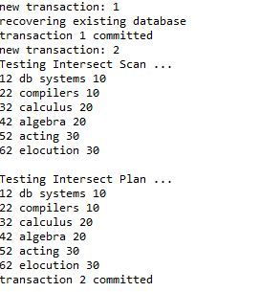

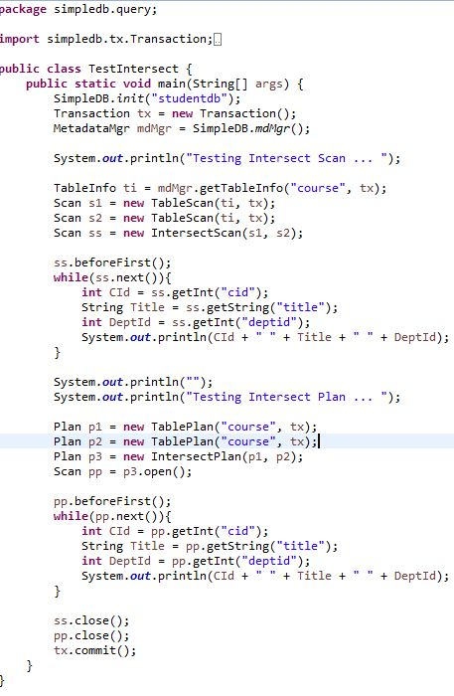

Problem 3:

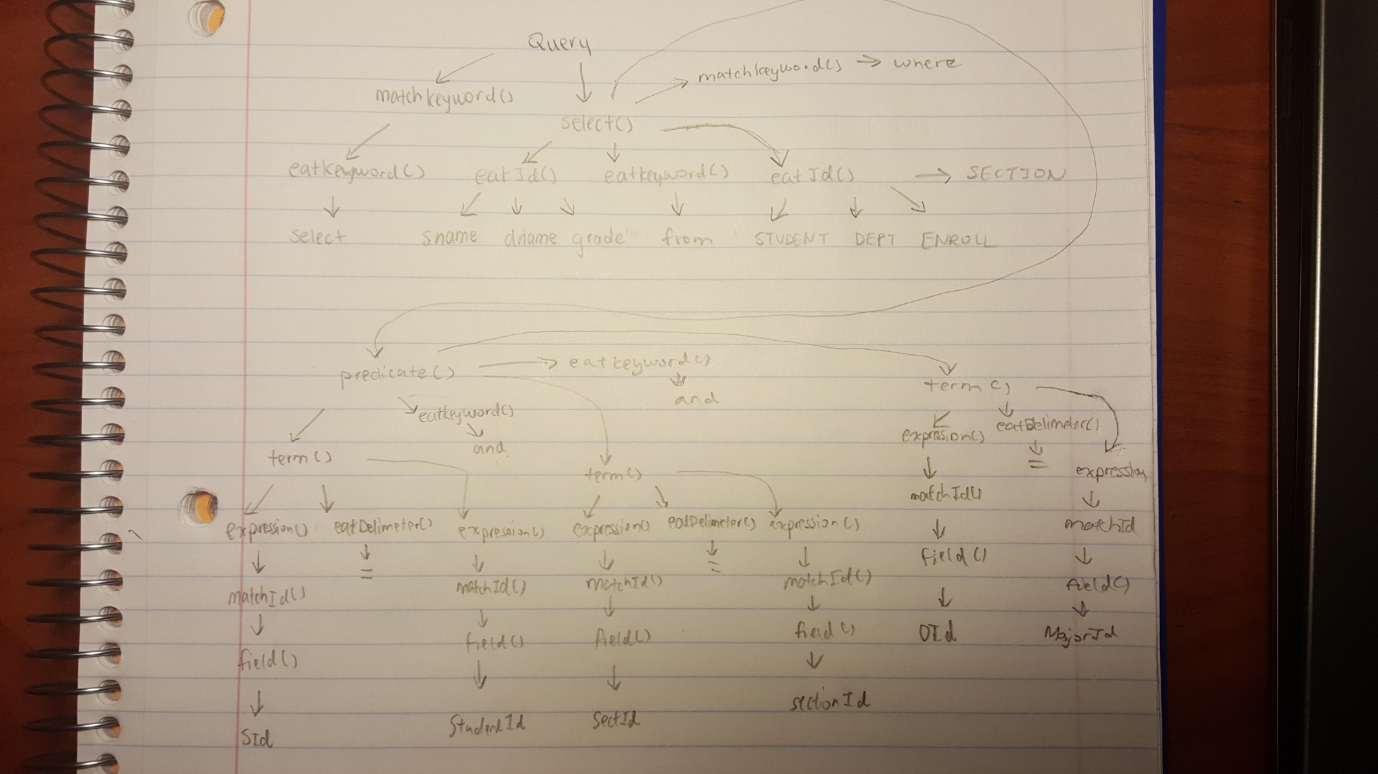

Problem 4

: 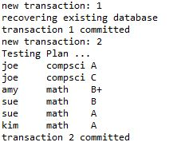

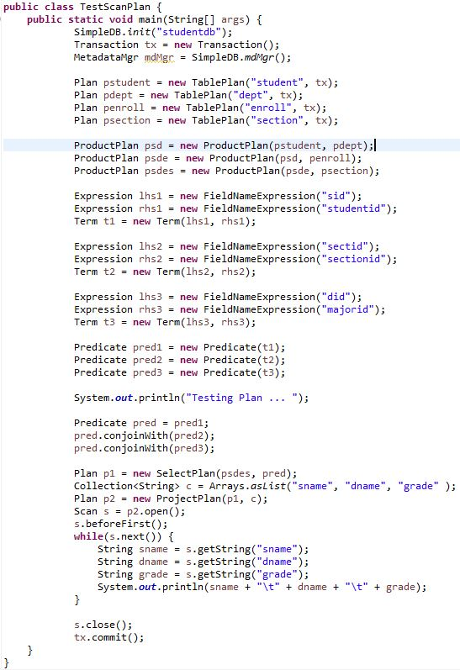

Problem 5:

INSERT x INTO

* A BadSyntaxException occurred because our parser was expecting the INTO keyword after INSERT. The value x is not listed as a keyword in the iniKeywords(). This occurs on line 135 in parser.java where the insert() method expects to eat two keywords and is thrown on line 119 in Lexer.java

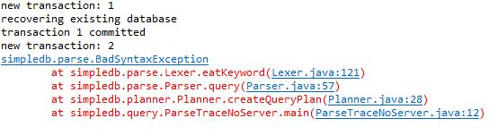

INSERT INTO x ( x x )

* A BadSyntaxException occurred because our parser was expecting a list. The given input contains two arguments that are not separated by commas. Because there is no comma, the parser expects the next token to be the delimiter ‘)’. This occurs on line 140 in parser.java and is thrown on line 81 in Lexer.java.

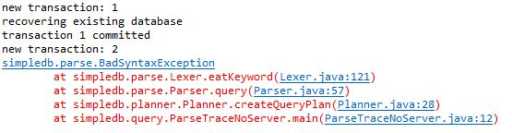

INSERT INTO x (x) VALUES x

* A BadSyntaxException occurred because our parser requires a corresponding list for values. The error is thrown when the parser expects to eat the ‘(‘ delimiter, however gets the value x. This occurs on line 141 in parser.java and is thrown by line 81 in Lexer.java

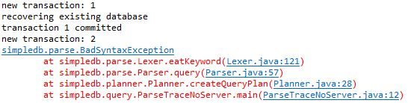

UPDATE x SET x=y;

* A BadSyntaxException occurred because our parser was expecting an expression rather than a fieldname. This occurs on line 178 in parser.java in the modify method when we initialize a new predicate where the exception is thrown on line 91 in lexer.java. Because y is not a constant, the parser tries to parse the expression y as an integer.

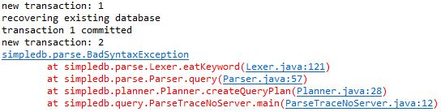

An Aggie does not lie, cheat, steal, or tolerate those who do.